General Rules:
Rule (10): The Arabic language has the following type of words: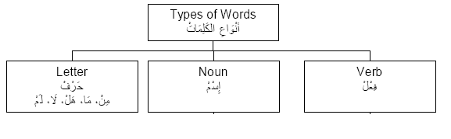
Rule (20): The Arabic Language has the following Sounds of letters:
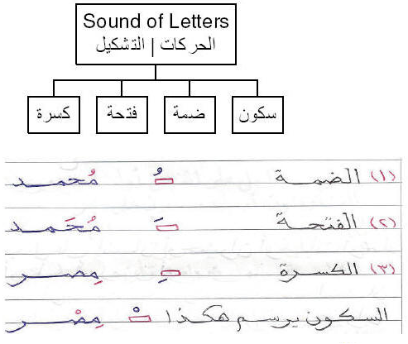
Rule (30): All Harakat can have Tanween (double Harakh) except the Sokoon.

