The Noun:
Examples of Nouns
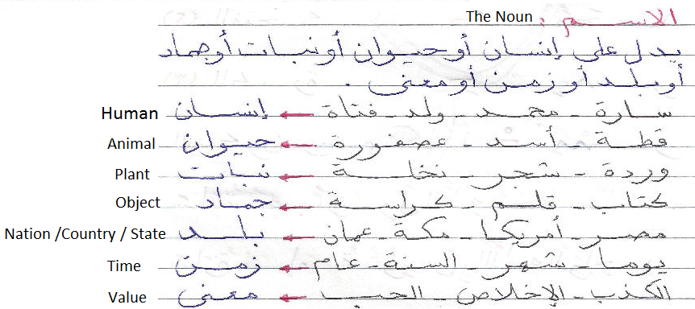

Rule (100): Nouns are divided by Gender as follows:
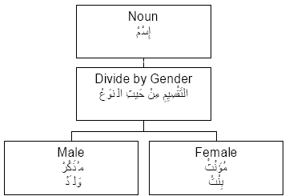

Rule (110): Names are divided by count as follows:
