Verb Sentences - Past Tense
الْفِعْلِ الْمَاضِي
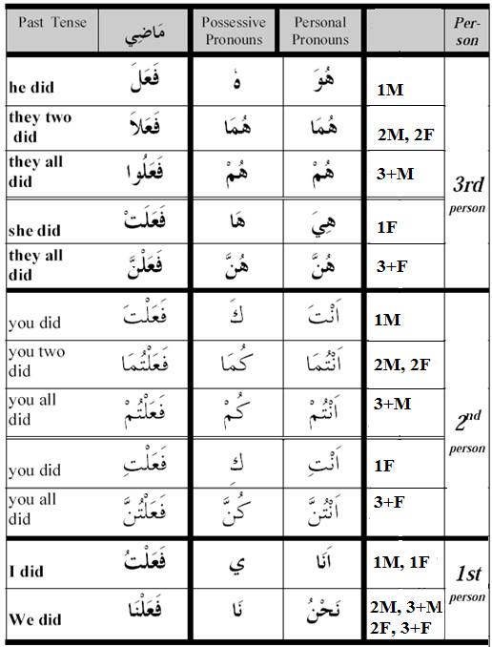
Notes:
- 2M and 2F are always the same.
- The first person has only two cases; singular and plural.
Rule 700: The past tense verb grammar is always Fatha, no exceptions, i.e. مَبْنِي عَلَىَ الْفَتْحَةْ
Rule 710: The نَّ in the 3+F is called Noon Al-Niwah or Women Noon النِسْوَة
Rule 720: The Alif at the end of the 2M and 2F is called Alif Al-Mothana or Alif of Double أَلِفْ الْمُثَنَّىَ
Rule 730: The نَا at the end of 1st person 2M, 3+M, 3F and 3+F is called Na of multiple doers
نَا الدَالَةُ عَلَىَ الْفَاعِلِيِنْ

